Create 20 files with .txt extensions:

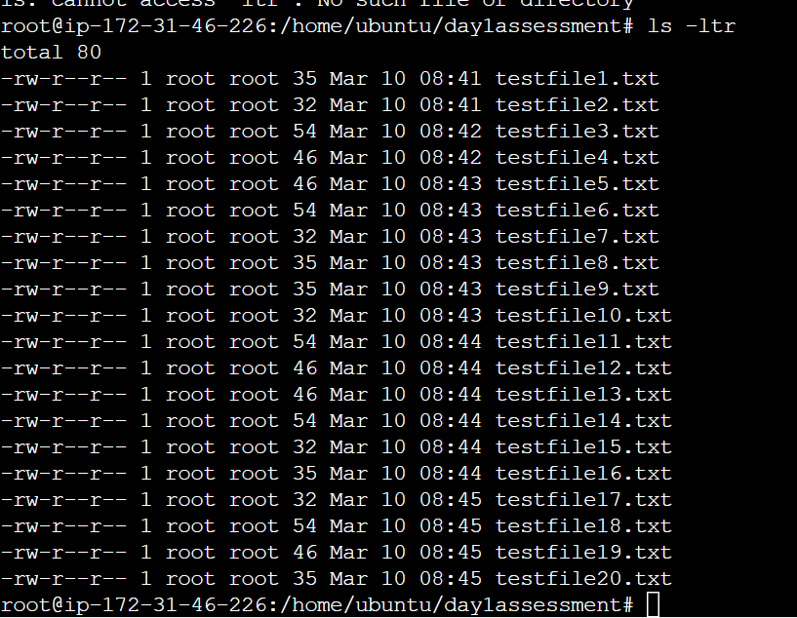

Rename the first 5 files to .yml extension:

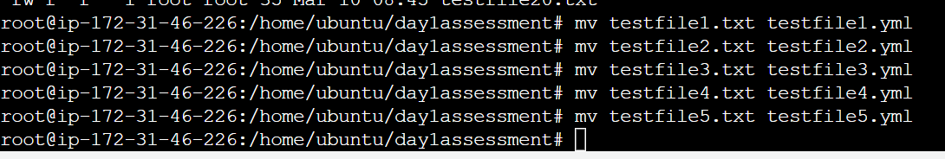

Print the latest created top 5 files among the total no of files:

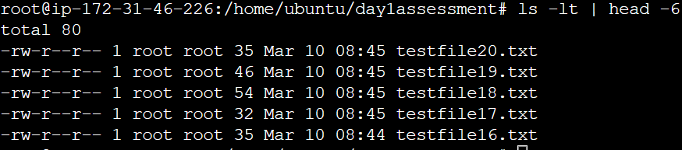

Print latest renamed top 5 files among the total no of files:

